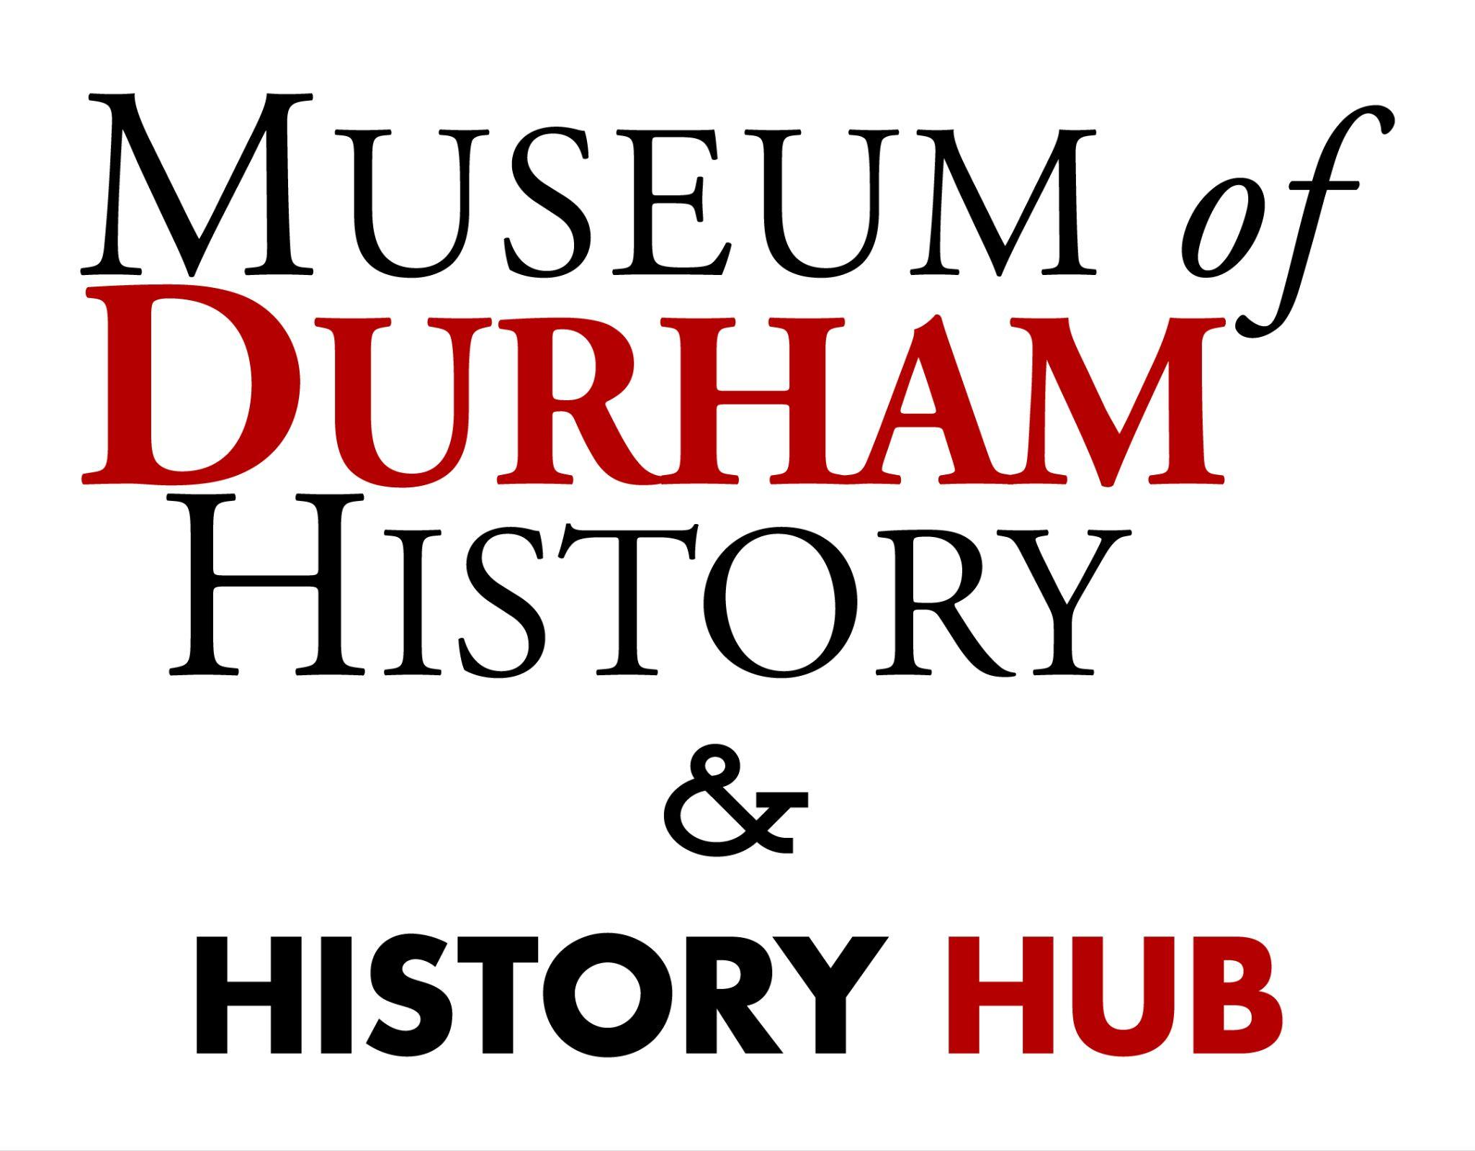

**2024-2025**

**MoDH SCAVENGER HUNT**

Welcome to our museum! We’re so happy y’all are here!

All the answers can be found on the museum property (we have exhibits indoors and outdoors), but in case your group runs out of time or has trouble finding an answer; ask the front desk for help or for the answer sheet.

This activity can either be completed as a group with the Teacher reading the questions aloud, or students are able to complete the activity individually, or in small groups.

**SCAVENGER HUNT QUESTIONS FOR ELEMENTARY SCHOOLERS**

1. Which animal is associated with Durham, and where can you find a picture of it in the museum?

__________________________________________________________

2. Back in the 1950s and 1960s you could get a frozen treat there, and people fought for equal rights there as well. What is this former shop sign that you can find hanging in the museum?

__________________________________________________________

3. This used to be the tallest building in Durham. Where in the museum do you see a picture of this building, and what is the building’s name?

__________________________________________________________

4. These things are bad for your health but they used to support Durham’s economy starting in the 1800s. Can you find this artifact?

__________________________________________________________

5. This lady came from a very humble home that you can still visit in Durham. I’ll give you a hint; her husband was a “Duke”. Can you find her picture?

__________________________________________________________

6. This thing hangs on the wall in the museum and tells us all about Durham’s history and landmarks. What is it?

__________________________________________________________

7. This tall building can still be seen from the windows in the museum and used to be home to a historic African American-owned company. Can you point to it?

__________________________________________________________

8. What building material were the old warehouses in town made of?

__________________________________________________________

9. Which building used to be the old home of Durham Central High School?

__________________________________________________________

10. **BONUS**: You may have noticed it on the way in (on the panels outside) but what was this building before it became a museum?

__________________________________________________________

**SCAVENGER HUNT QUESTIONS FOR MIDDLE SCHOOLERS**

1. Why is Durham’s mascot a bull?

__________________________________________________________

2. What world famous building (not in Durham) did the architects who designed the Hill Building design as well?

__________________________________________________________

3. Who was the niece of Richard Fitzgerald, who became a Reverend, a Doctor, and a Civil Rights Activist, who has many murals in Durham?

Hint: There is a quarter with her face on it!

__________________________________________________________

4. Who perfected the curing of yellow tobacco? Hint: check out the story room quilt!

__________________________________________________________

5. How did the Dukes make their fortune before Duke university?

__________________________________________________________

6. What was the area called when the Eno and Occoneechee tribes lived here?

__________________________________________________________

7. What was the dollar amount paid out by NC Mutual Life Insurance for their first death benefit claim?

__________________________________________________________

8. What material were old tobacco factories and warehouses made of?

__________________________________________________________

9. Thinking about the building MoDH is in: What was this building before it was a bus station? Hint: You may have to go outside…

__________________________________________________________

10. **BONUS:** Who was the president of the old DHS (Durham High School) Ukulele club in 1921?

__________________________________________________________