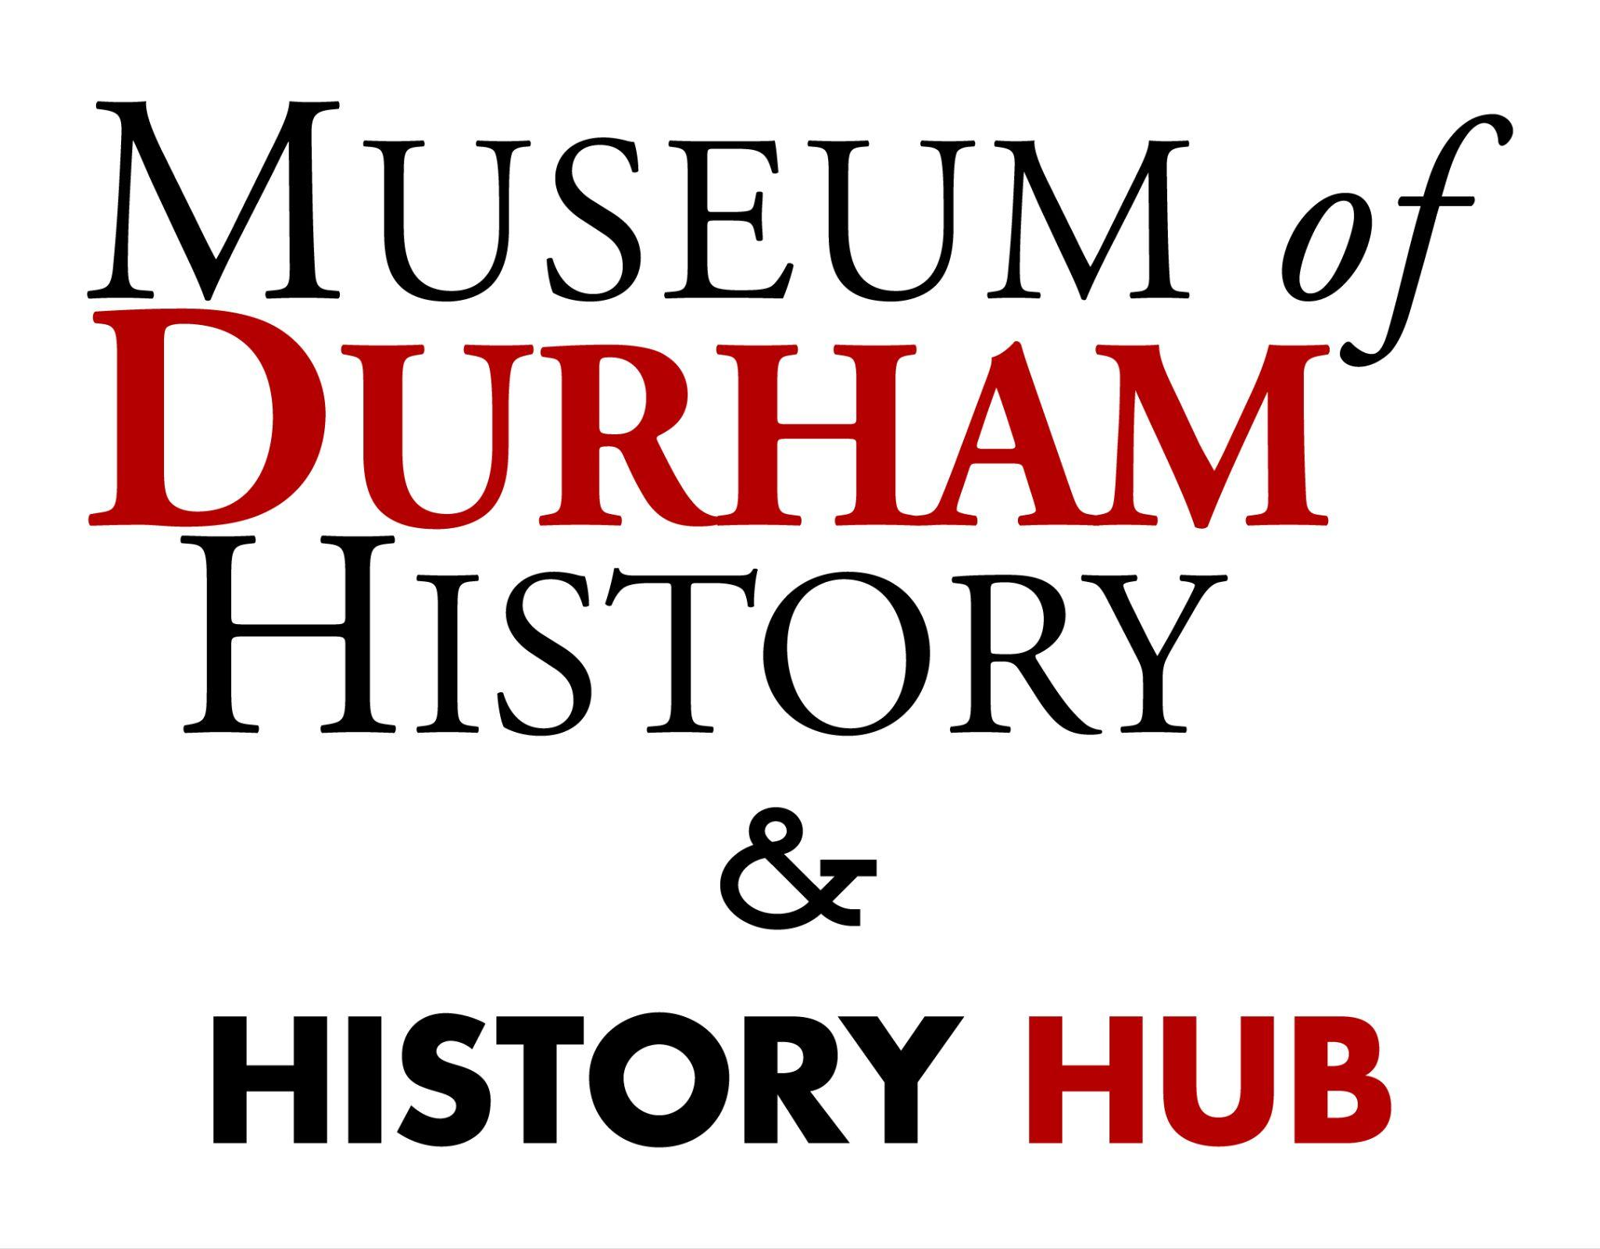

**“I Spy” at the Museum of Durham History!**

**I SPY** a bull with a yellow background…

What condiment led to the nickname ‘Bull City’? 🐂 __________________

Bonus: what is the Durham Bulls’ mascot name? ⚾ ________________

**I SPY** a big sign with red and green letters…

In which year did the first documented civil rights sit-in in North Carolina take place? 🍦🕰️ ____________________

Bonus: what is a “sit-in”? 🪑___________________

**I SPY** a row of small houses… 🏠

Who used to live on this road? ____________________

**I SPY** a colorful quilt on the wall… 🧵

Who was the person who perfected “brightleaf” tobacco? _________________

Hint: check the bottom right corner of the quilt! ⬇️

**I SPY** a map on the wall… 🗺️

What was Durham before it became a town? 🚂 ____________________