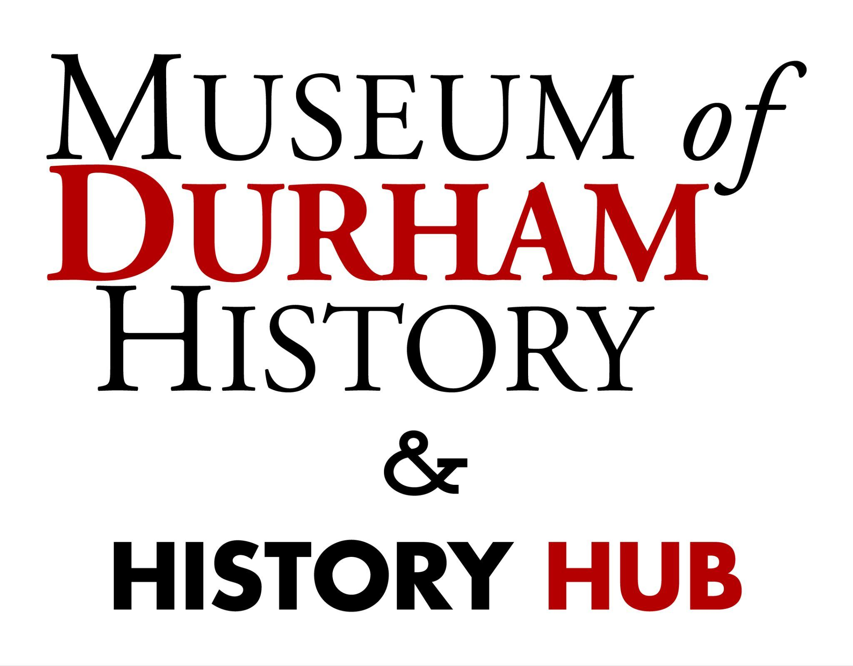

**Pre Visit Vocabulary List**

**Artifact:** An object made or used by people in the past that helps us learn about history, culture, or daily life.

**Civil Rights:** Basic rights that all people should have, like fairness and equality, no matter their skin color, beliefs, or background.

**Culture:** The beliefs, customs, arts, and way of life of a particular group or society.

**Curator:** Someone whose job is to take care of the objects in a museum.

**Emancipation:** The act of setting someone free from slavery.

**Endowment:** Money given to help support an organization, like a school or museum, usually for a long time.

**Enslaved:** A person forced to work without pay and without freedom.

**Exhibit:** A public display of works of art, history, or other items of interest, held in a gallery or museum.

**Heritage:** The traditions, history, and important cultural achievements passed down from previous generations.

**History:** The study of past events; events of the past; past events that relate to a particular subject, place, organization, etc.

**Interpretation:** The act of explaining or giving meaning to something, like an artifact or story in a museum.

**Manufacturer:** A person or company that makes products, like toys, fabrics, or furniture, in large amounts.

**Museum:** A building where many valuable and important objects and stories about the past are shared with the public.

**Non-Profit:** An organization that uses any money it earns from events, donations, or grants to support its mission of preserving and sharing art, history, or science, rather than making a profit for owners.

**Oral History:** A way of learning about the past by talking to people who share their personal stories, memories, and experiences.

**Philanthropist:** A person who donates money, time, or resources to help make life better for others.

**Physician Assistant:** A trained medical professional who helps doctors take care of patients.

**Preservation:** The act of keeping something in its original condition or protecting it from being damaged or changed.

**Primary Source:** An original document, object, or other item created at the time being studied, like a diary, photograph, or artifact.

**Secondary Source:** Information about the past created after the time being studied, like a history book or documentary.

**Segregation:** When people are kept apart because of their race, religion, or other differences.

**Sharecropper:** A farmer who grows crops on someone else's land and shares part of the harvest with the landowner.

**Sit-In:** A peaceful protest where people sit in a place and refuse to leave until they are heard.

**Tenant:** A person who pays to live in a house, apartment, or land that belongs to someone else.

**Textile:** Cloth or fabric made from materials like cotton or wool, used to make clothing and other items.

**Tobacco:** A plant whose leaves are dried and used in products like cigarettes.

**Urban Renewal:** A program designed to improve a city area by fixing old buildings and making it nicer to live in. Unfortunately, this was used to displace many African Americans and people of color.